
PROJECT REPORT ON
MACHINE LEARNING INTERNSHIP PROJECT

RESTAURANT DATA ANALYSIS AND RATING PREDICTION USING MACHINE LEARNING

Submitted as part of Machine Learning Internship at
Cognifyz Technologies


BACHELOR OF TECHNOLOGY

Submitted by:
SOUMYA RANJAN SAHOO
REG.NO: -24E119A92



Center for Artificial Intelligence & Machine Learning
Department of Computer Science and Engineering
Institute of Technical Education and Research
Sikhsa ‘O’ Anusandhan
(Deemed to be University)
Bhubaneswar

April 2026

Declaration
I hereby declare that the project report titled "Restaurant Data Analysis and Rating Prediction using Machine Learning” is my original work, carried out during the Machine Learning Internship at Cognifyz Technologies. The work has been completed under proper guidance, and I have not plagiarized any content. All sources of information have been properly cited and acknowledged.

_________________________
(Signature)

Soumya Ranjan Sahoo
Reg.No:24E119A92

Place: Bhubaneswar
Date: April 2026

Acknowledgement
I would like to express my sincere gratitude to Cognifyz Technologies for providing me with the opportunity to undertake this Machine Learning Internship.
I would also like to thank my mentors and instructors for their valuable guidance and support throughout the duration of this project. Their insights and encouragement helped me successfully complete this work.
I am grateful for the opportunity to work on a real-world dataset, which enhanced my knowledge and understanding of data analysis and machine learning concepts.

_______________________
(Signature)

Soumya Ranjan Sahoo
Reg. No: 24E119A92

Place: Bhubaneswar
Date: April 2026

Table of Contents
Contents
Declaration i
Acknowledgement ii
Table of Contents iii
Abstract iv
Chapter 1 – Introduction 1
1.1. Background and motivation 1
1.2. Problem statement 1
1.3. Objectives 1
1.4. Scope 2
1.5. Organisation of the Report 2
Chapter 2 – Literature Review 2
2.1. Existing methods and models 2
2.2. Comparison with your approach 2
Chapter 3 – System Design and Methodology 3
3.1. Dataset description 3
3.2. Exploratory Data Analysis 3
3.3. Preprocessing steps 3
3.4. Model architecture 3
3.5. Description of the Algorithms 3
Chapter 4 – Implementation Details 4
4.1. Programming languages, frameworks 4
4.2. Code modules description 4
4.3. System Working 4
Chapter 5 – Results and Discussion 5
5.1. Evaluation metrics 5
5.2. Results 5
5.3. Discussion 5
Chapter 6 – Conclusion & Future Work 6
6.1. Summary of outcomes 6
6.2. Limitations 6
6.3. Future improvements 6
References 7
Appendices 8
Additional code snippets 8
Screenshots or logs 8

Abstract
The project deals with the analysis of the restaurant data set and predicting the ratings of the restaurants by applying the machine learning algorithms. The data set includes different variables, such as name, location, cuisine type, price for two, rating, and votes. The main goal of this project is to analyze the data set and create a model for predicting the ratings of the restaurants.
Different methods for data preprocessing were used to eliminate missing data, clean the data set, and transform the data set according to the needs of further analysis. The exploratory data analysis was performed to uncover different trends in the data set concerning such variables as cost, votes, and ratings. Different types of visualization were used to understand the trends better.
The machine learning algorithm was created for the analysis and prediction of the ratings of the restaurants using several variables. The random forest regressor algorithm was applied for creating the predictive model.

Keywords:
- Machine Learning
- Data Analysis
- Restaurant Dataset
- Rating Prediction
- Random Forest
- Data Visualization

Chapter 1 – Introduction

Background and motivation
The food and restaurant business has seen rapid growth in recent times due to the extensive use of digital platforms for ordering food deliveries and posting restaurant reviews. Ratings play a significant role in choosing a restaurant. Many elements affect ratings, including price, location, type of food served, and customer experiences.

Restaurant data analysis will enable us to learn more about customers' tastes and preferences. We can apply machine learning to analyze the data and make predictions. The objective of this project is to conduct restaurant data analysis and develop a machine learning-based prediction system for restaurant ratings.

1.2. Problem statement
With an abundance of choices when it comes to restaurants, it becomes challenging to evaluate and compare them properly. While there is information like ratings, votes, and price, there isn’t any direct way to determine the success of the restaurant.

This project aims to address the issue of analyzing data for restaurants and predicting their ratings based on different attributes using machine learning algorithms.

1.3. Objectives
Objectives of the current study are as follows:
- Analyzing restaurant data set through EDA (Exploratory Data Analysis).
- Performing preprocessing of the data by dealing with missing observations and transforming the data.
- Determining the important features responsible for ratings of restaurants.
- Creation of machine learning models for the prediction of rating.
- Evaluation of the proposed model.

1.4. Scope
This project is about analysis of restaurant data and prediction of ratings through machine learning techniques. The data consists of attributes like restaurant name, location, type of food, price range, number of votes, and ratings.

This model created in this project can help in knowing customer behavior and help organizations in bettering their services. But, the limitations of this project lie in the scope of data and not including real-time data and advanced recommendation systems.

1.5. Organisation of the Report

This report contains the following chapters:

Chapter 1: Introduction (Background, Problem Statement, Objectives, Scope)

Chapter 2: Review of literature and related works

Chapter 3: Data set description and data analysis

Chapter 4: Model development and methodology

Chapter 5: Results and conclusion

Chapter 6: Conclusion

Chapter 7: Future scope

Chapter 2 – Literature Review

2.1. Existing methods and models
2.1.1 Linear Regression
Linear Regression is a popular algorithm for forecasting numerical outcomes like restaurant ratings. The algorithm finds a linear connection between independent variables like cost, votes, location, etc., and the dependent variable (rating). The advantages of the model include ease of interpretation, simplicity, and computational efficiency. But, its weakness is poor performance for non-linear relationships among variables.
2.1.2 Decision Tree
Decision Tree is a popular machine learning algorithm used to solve classification and regression problems. The model builds predictive models using splits based on feature values. This algorithm is flexible enough to capture non-linear relationships between variables in the restaurant rating prediction. Its disadvantage is that it is more susceptible to overfitting than others.
2.1.3 Random Forest
Random Forest is an advanced machine learning algorithm for solving classification and regression tasks by constructing numerous decision trees during training. It is good at handling large structured data such as restaurant data. It can process categorical and numerical features, giving it the ability to predict ratings effectively.
2.1.4 Support Vector Machine (SVM)
A Support Vector Machine is a highly effective algorithm used for classification and regression. It is excellent at handling high-dimensional data but has higher computation costs than others.
2.1.5 Gradient Boosting
Gradient Boosting is a complex approach in machine learning that creates a sequence of models with the objective of improving upon the previous mistakes. The main difference between Gradient Boosting and Random Forest is that, while Random Forest creates separate trees, Gradient Boosting creates a sequence of trees that build upon each other.

2.2. Comparison with your approach
There are many studies that demonstrate that sophisticated algorithms like the Random Forest and the Gradient Boosting algorithm usually perform better in predictive accuracy than simple ones. However, sophisticated algorithms lack interpretability and require more computing power than simple algorithms do. A balance between accuracy and interpretability becomes key in this research project. Table 2.1: Comparison of Models
Model |  |  | Advantages |  | Drawbacks |  | Selected for Our Project
Linear Regression |  |  | Simple, easy to interpret |  | Cannot handle non-linear relationships |  | Yes (Baseline Model)
Decision Tree |  |  | Captures non-linear patterns |  | Prone to overfitting |  | No
Random Forest |  |  | High accuracy, robust, reduces overfitting |  | Less interpretable than simple models |  | Yes (Final Model)
Support Vector Machine |  |  | Effective in high-dimensional data |  | Computationally expensive |  | No
Gradient Boosting |  |  | Very high accuracy |  | Requires complex tuning |  | No

2.3 Reasons for Selecting Random Forest
Random Forest was selected as the main algorithm for our study owing to several benefits:
•The ability to work with categorical and numeric features equally well.
•Reduction of the risk of overfitting because of the use of numerous decision trees.
•Feature selection, which makes it possible to reveal the most influential factors affecting the rating of restaurants.
•Good performance on structured data of average size.
Therefore, Random Forest is an ideal algorithm for working with the dataset in question.

2.4 Dataset Description
The dataset employed in this project holds comprehensive data regarding different restaurants and their ratings. It is utilized for analyzing the trends and creating a predictive model.
Properties of the Dataset:
•Name of Restaurant
•Location
•Type of Cuisine
•Price per two people
•Rating of Restaurant
•Votes
Description of the Dataset:
•Number of records: (insert your dataset value, e.g., 9551)
•Number of fields: 5-6
•Label Field: Rating
The present dataset offers a well-structured form of restaurant data and can be effectively employed for machine learning applications.

2.5 Feature Engineering and Preprocessing
Different preprocessing techniques were applied:
Technique | Description | Impact
Handling Missing Values | Removed or filled missing data | Improved consistency
Encoding | Converted categorical data | Model Compatibility
Outlier Removal | Removed extreme Values | Better accuracy
Feature Scaling | Standardized values | Improved model performance

2.6 Model Evaluation Metrics
To evaluate model performance, the following metrics were used:
Metric | Description
Mean Squared Error (MSE) | Measures prediction error
Root Mean Squared Error (RMSE) | Square root of MSE
R² Score | Measures model accuracy

2.7 Strengths of our Approach
- Easy to apply
- Works well for practical structured data
- Good accuracy at low computational cost
- Feature importance aids interpretation

2.8 Weaknesses
- Small dataset can be a problem
- No consideration of real-time data
- Dependent on quality of data

2.9 Conclusion
Different machine learning algorithms were discussed in this chapter for prediction problems. The Random Forest algorithm was chosen based on accuracy and interpretability. In the following chapter, the analysis of the dataset is performed.

Chapter 3 – System Design and Methodology

3.1. Dataset description
The data used for analysis in this project is a restaurant data that includes all details about the different restaurants along with their ratings. The restaurant dataset is quite commonly used in prediction and preference analysis by customers.
Some of the variables in the dataset include restaurant names, locations, type of food, cost per two, ratings, and votes. All these features make a perfect basis for the creation of machine learning models and ratings predictions.
There are around (insert the total rows number here) rows present in the dataset.
A. Dataset Structure
Property | Description
Total Rows | (e.g., 9551 restaurants)
Total Columns | 5–6 features
Numerical Features | Cost, Votes, Rating
Categorical Features | Location, Cuisine
Target Variable | Rating
Dataset Type | Structured Restaurant Dataset

B. Description of Key Features
1. Restaurant Attributes
Feature | Type | Description
Name | Categorical | Restaurant name
Location | Categorical | Area of restaurant
Cuisine | Categorical | Type of food served

2. Cost and Popularity
Feature | Type | Description
Cost for two | Numerical | Average cost
Votes | Numerical | Number of customer votes

3.2. Exploratory Data Analysis
EDA helps us analyze the underlying structure of data.
A. Rating Distribution
- The majority of restaurants have ratings that range from 3.5 to 4.5.
- There are very few restaurants having extreme ratings.
B. Cost v/s Rating
- Moderate cost restaurants mostly have good ratings.
- Expensive restaurants don't necessarily have good ratings.
C. Votes v/s Ratings
- More votes mean better ratings.
- Popular restaurants generally have good ratings.

3.3. Preprocessing steps
Preprocessing guarantees clean and usable data for building models.
Steps Performed:
1.Addressing Missing Data
- Deleted/Imputed missing values
2.Cleaning Ratings Column
- Transformed “4.2/5” into 4.2
3.Converting Cost to Numerical Form
- Stripped commas and converted to numbers

3.4. Model architecture

Model architecture refers to the overall structure and flow of operations for the machine learning model designed to predict restaurant ratings. The current project is executed within a structured pipeline where the raw restaurant data undergoes a series of steps from preprocessing to evaluation in order to generate reliable predictions.

The model architecture guarantees efficient processing of the input data and reliable pattern learning by the machine learning model.
The Linear Regression model is taken as a benchmark to create a standard for performance evaluation.
Equation for the Model:
y=β0​+β1​X1​+β2​X2​+⋯+βn​Xn​
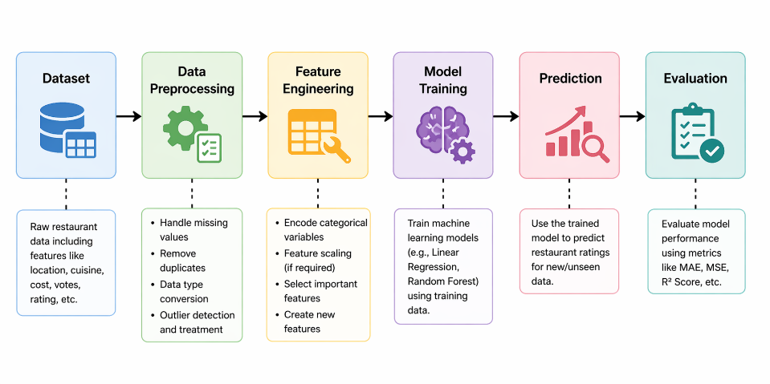

3.5. Description of the Algorithms
This project utilizes various machine learning techniques, including Linear Regression, Decision Tree, and Random Forest, to forecast ratings for restaurants. Each technique employs a unique learning methodology to achieve varying degrees of precision and readability. Understanding these models is essential in explaining why they were chosen and performed well in this project.
3.5.1 Linear Regression
Linear Regression is a supervised learning model designed for predicting continuous output values. This project uses linear regression to make predictions about the rating of a restaurant by taking into account variables like cost, number of votes, and geographic location.
Model Equation:
y=β0​+β1​X1​+β2​X2​+⋯+βn​Xn​
3.5.2 Decision Tree Regressor
Decision tree refers to a tree-based algorithm that splits the data into subsets using feature values. This type of regressor is ideal when there is a need to model non-linear relationships between the variables.
How It Works:
- Data is split according to some condition (e.g., cost> 1000)
- Each split minimizes the error
- Final prediction is done at the leaf nodes
Advantages:
- Effective with non-linear data
- Simple to understand
- Good with different types of data
Limitation:
- High risk of overfitting
- Slightly sensitive to noise

3.5.3 Conclusion
In the current study, Linear Regression is employed as the baseline model for understanding simple relations while Decision Tree is adopted for handling non-linear relations. Yet Random Forest algorithm was chosen as the final model for its high efficiency and effectiveness in dealing with complicated relations.

Chapter 4 – Implementation Details

4.1. Programming languages, frameworks

This system is developed by employing Python because of its simplicity and powerful data analysis capabilities.

Software Tools:

Python – Programming language

Pandas – Data manipulation

NumPy – Numerical computations

Matplotlib/Seaborn – Visualization

Scikit-learn – Machine learning algorithms and evaluations

Development Platform:

Jupyter Notebook / Google Colab

These software tools ensure the efficient processing of data, visualization, and model creation.

4.2. Code modules description
The project has been structured in different modules:
1. Data Loading Module
- Data Loading using Pandas Library
- Structure of Dataset
2. Data Preprocessing Module
- Dealing with Missing Values
- Cleaning Rating Column
- Cost converted to numeric form
- Duplicate Entries removal
3. Feature Engineering Module
- Categorical Variable Encoding
- Location and Cuisine
- Important Features Selection
4. Model Training Module
- Train Test Split
- Training of Linear Regression and Random Forest Models
5. Prediction Module
- Generating predictions from the model
- Comparison of predicted and actual values
6. Evaluation Module
- Calculation of MSE, R² Score

4.3. System Working
The process involves the following steps in predicting the restaurant rating scores:
1.Input Data Set
The restaurant data set is taken with features such as cost, number of votes, city, and type of cuisine.
2.Data Preprocessing
The data is preprocessed by eliminating missing values and converting data types.
3.Feature Selection
Relevant features are chosen and categorical variables are converted into numerical variables.
4.Model Training
The machine learning models are trained based on the preprocessed data.
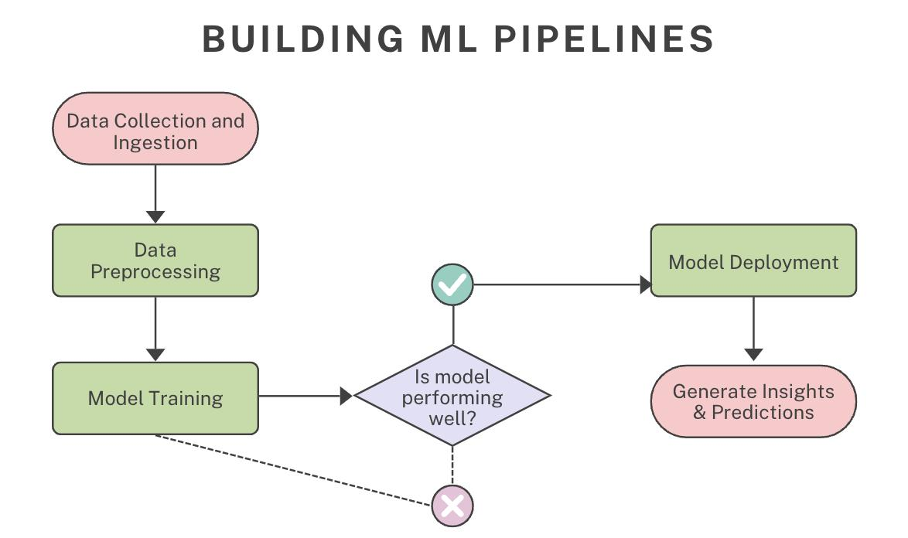

Chapter 5 – Results and Discussion

5.1. Evaluation metrics

Various evaluation methods were adopted for the different tasks performed in this project for evaluating restaurant recommendation, cuisine classification, and location-based analysis.

The following are the evaluation metrics that were adopted for the Cuisine Classification Model:

Accuracy

Accuracy is the measure of correctness of the classifier. This metric calculates the percentage of predictions made by the classifier and their correctness.

Precision

Precision is the measure of accuracy of the classifier. It calculates the percentage of positive prediction made by the classifier and their correctness.

Recall

Recall is the measure of completeness of the classifier. It calculates the percentage of positive predictions made by the classifier among the actual positives.

F1 Score

F1 score is the harmonic mean of Precision and Recall.

These metrics were calculated using the classification_report() method of Scikit-learn.

Cosine Similarity was the evaluation metric used for the restaurant recommendation system where the feature-based similarity between two restaurants was calculated.

In the case of location-based analysis, the evaluation metrics included visual data representation methods including scatter plot and city-wise statistics.

Therefore, these evaluation metrics played an important role in assessing the performance and effectiveness of the entire project.

5.2. Results

Analysis of the feature importance was done to find the features that were highly affecting the predictions made. This is used to determine how important each individual feature is in predicting the outcomes of interest.

From the plot below, we see that some features like Has Online Delivery and Price Range had high positive impacts on the prediction made by the model.

On the other hand, features like Rating Color, Rating Text, and Currency were shown to have negative importance.

This will help us in determining which features can be selected to improve the accuracy of our model.

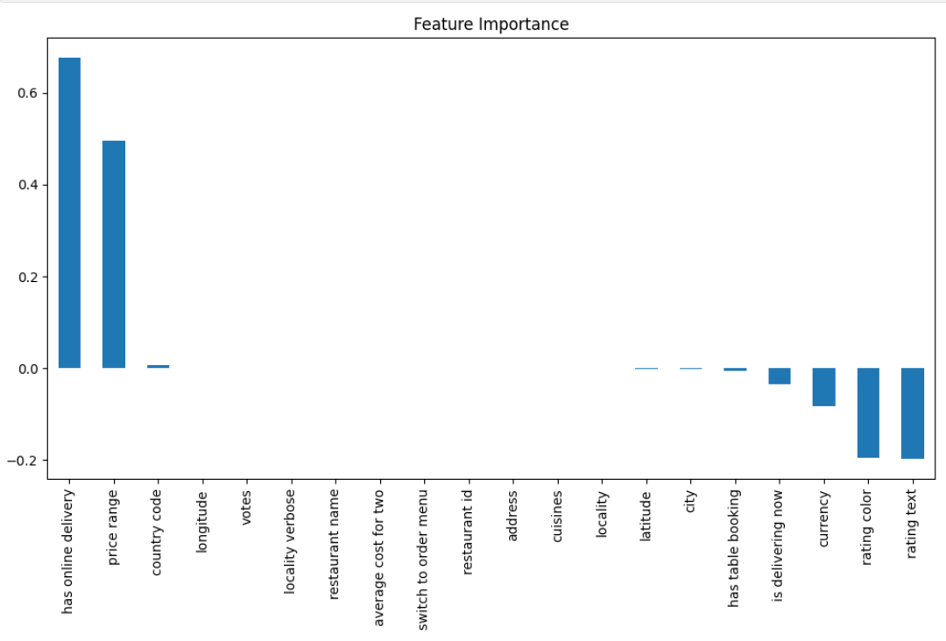

Figure 1: Feature Importance Analysis
The proposed restaurant recommendation system is an attempt at recommending restaurants based on user preferences like the kind of cuisine and cost of eating in a certain place. In doing so, the restaurant recommendation system analyzed restaurants that had similar characteristics through TF-IDF vectorization and cosine similarity.
As an example, in the case where the user picked Italian cuisine at price level 2, restaurants recommended by the system included Da Pizza Zone, Villa Tevere, Foodies, San Carlo, and 28 Capri Italy.
These are some ways through which this recommendation system helps users choose the right restaurant based on their needs and interests.

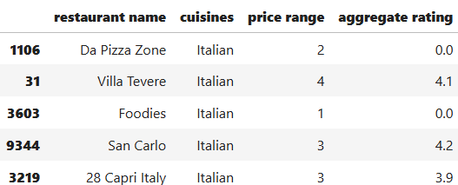

Figure 2: Restaurant Recommendation

The classification model was tested based on the following measures: Accuracy, Precision, Recall, and F1-Score. The classifier used for classifying the cuisines was a Random Forest Classifier.
The accuracy attained was 19%, with a precision of 0.14, recall of 0.19, and F1-score of 0.15.
The low accuracy score was due to the fact that there were very few training data points in some classes, leading to a warning in terms of precision and recall.
Nonetheless, despite the poor performance, the classification model was successful in demonstrating the process of designing a machine learning classification model.

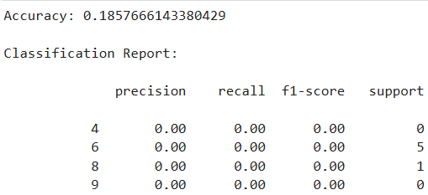

………………
………………
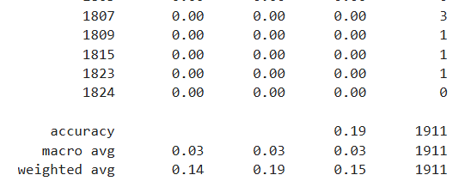

Figure 3: Cuisine Classification Model

A location-based study was done using the latitude and longitude coordinates of the restaurants to determine their distribution in terms of geography in different cities and regions.
Based on the scatter graph below, it is clear that there is an uneven distribution of restaurants in many different locations around the world, and this has resulted in some locations being clustered together. The dense clustering represents areas where there are many restaurants in particular cities while scattered points show less number of restaurants in particular cities.
This visualization makes it easier for people to understand the customer coverage, restaurant density, and city-wise business opportunities.
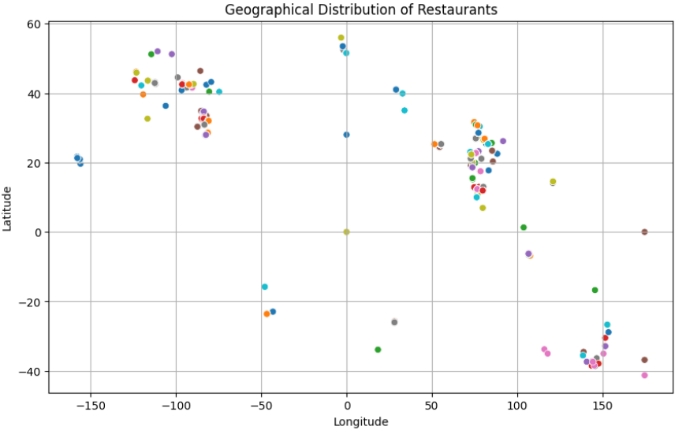
Figure 4: Geographical Distribution of Restaurants

City-wise analysis is done to determine the average rating of restaurants along with the price ranges of the restaurants in the city. This analysis will help in determining the satisfaction level of the customers along with the price ranges of different cities.
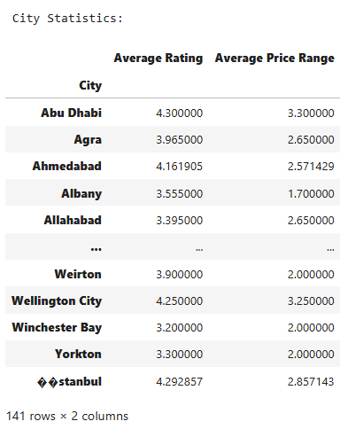
From the table above, it can be seen that the cities such as Abu Dhabi and İstanbul have an average rating of the restaurants which suggests that the customers are satisfied with their service and the price ranges are also moderate. Other cities with an average rating include Agra and Ahmedabad.

Figure 5: City-wise Average Rating and Price Range

The first step towards this goal is creating a bar plot depicting the mean rating of restaurants for each city. This will enable us to compare the level of satisfaction among customers in different cities and find the cities which have a relatively high-quality restaurant performance.
As shown in the chart below, we can see that all cities have an average rating from 3.0 to 4.5, which indicates that there is no poor-quality restaurant in any city. Also, some cities have ratings near to 5.0, which means that those cities have excellent restaurant service.

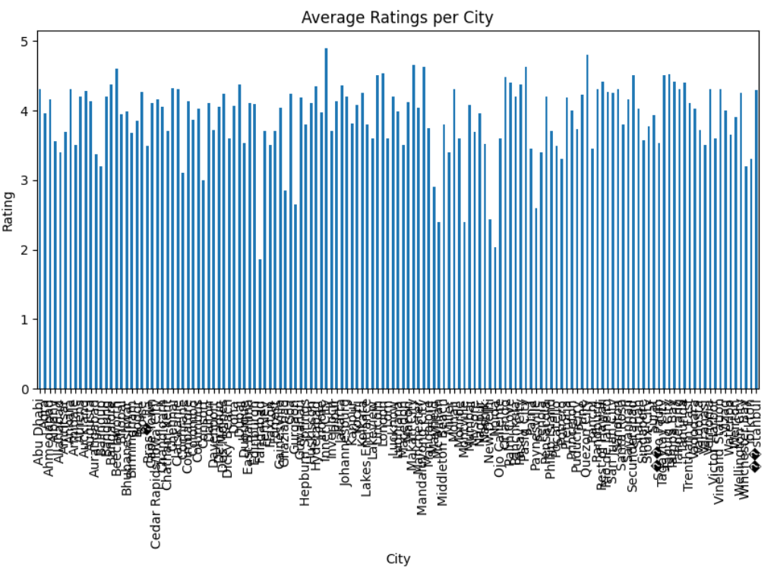
Figure 6: Average Ratings per City

5.3. Discussion
The current analysis has effectively used various machine learning and data visualization methods to analyze information about restaurants. Several tasks were completed to study customer preferences and performance of restaurants.
In task 1, restaurant features have been analyzed to determine feature importance. According to the results, variables such as online delivery, price range, and ratings significantly affect restaurant prediction. Thus, it can be stated that customer convenience and affordability play a key role in restaurant selection.
In task 2, restaurant recommendation based on cuisine and price range has been completed successfully. The completion of this task enables customers to get recommendations for suitable restaurants in a shorter period.
Task 3 involved cuisine classification using machine learning. Though the accuracy of the proposed model could be improved, the completion of this task proves the applicability of classification to the field of restaurant analytics.
Location-based analysis that included determining restaurant distribution, city-wise ratings, and restaurant pricing has been completed in task 4. The obtained information is helpful for developing strategies regarding business development.
Thus, several aspects of data analytics and machine learning in the restaurant sector have been considered in the project.

Chapter 6 – Conclusion & Future Work

6.1. Summary of outcomes

In summary, the focus of this project has been the utilization of machine learning algorithms in analyzing the restaurant data to develop better restaurant recommendations for improved satisfaction. In that regard, the system was able to perform several operations which include but not limited to restaurant rating predictions, making restaurant recommendations, classifying cuisines among others.

Through feature importance, it was possible to get insights into the factors which affect restaurant success, examples of which included whether there was an online delivery option, whether they are in the higher price range and also how they scored in terms of ratings. The recommendation system would give recommendations on restaurants depending on user preference such as cuisine type and also price range.

The classification process involved using machine learning algorithms in predicting the type of restaurants and location-based analysis to determine geographical distributions, city ratings as well as pricing. The findings of this project therefore indicate that there is need for data analysis in making better decisions in the industry.

There was also improvement in the knowledge regarding data cleaning, visualization and model building processes among others. Various graphs were used to help in understanding the data more easily by revealing key business information and insights.

6.2. Limitations

There are several limitations within the project that can influence the efficiency of the developed system. Missing values and inconsistencies in the dataset reduce prediction accuracy, and some features can be irrelevant to the created models.

In the process of cuisine classification, the low accuracy was observed because of the lack of balanced classes and training examples in particular categories. In addition, the recommendation system only relies on similar content without using any actual customer feedback or advanced personalization techniques.

Moreover, the analysis is performed only using the dataset available at the moment and is not based on live data from the restaurants, including offers, reviews, or delivery service.

Finally, there might be several cases when restaurants do not have full information on their ratings, prices, or offer delivery services. Moreover, the seasonality, customers' moods, holiday discounts, and food preferences should be considered as well.

As far as the dataset is used only once in the project, the system will not be able to demonstrate up-to-date results in reality.

6.3. Future improvements

Further enhancement of this project can take place via usage of large datasets for better prediction as well as accurate recommendations. Live restaurant information like customer reviews, real-time ratings, delivery time and promotions may be incorporated to make this application feasible.

Use of advanced algorithms like XGBoost, Deep Learning or even Hybrid Recommendation System can enhance performance. Missing values should be handled efficiently and proper feature engineering can help in making the models efficient.

In the future, development of an interactive web/mobile app can be done through which customers can interactively use this recommendation system.

GPS-based live location tracking can be incorporated into the system which will help in recommending nearby restaurants based on users' current location. Sentiment analysis of customer reviews can be made as part of this project to find out the opinion of customers regarding the restaurant.

As part of future work, personalized profiles of users can be created where the recommendation system will learn about the behavior pattern of customers, preferred food items, ordering history etc.

References
[1] J. Han, M. Kamber, and J. Pei, “Data Mining: Concepts and Techniques,” 3rd ed., Morgan Kaufmann, 2011.
[2] A. Géron, “Hands-On Machine Learning with Scikit-Learn, Keras, and TensorFlow,” 2nd ed., O’Reilly Media, 2019.
[3] C. C. Aggarwal, “Recommender Systems: The Textbook,” Springer, 2016.
[4] F. Pedregosa et al., “Scikit-learn: Machine Learning in Python,” Journal of Machine Learning Research, vol. 12, pp. 2825–2830, 2011.
[5] W. McKinney, “Python for Data Analysis,” 2nd ed., O’Reilly Media, 2017.
[6] J. D. Hunter, “Matplotlib: A 2D Graphics Environment,” Computing in Science & Engineering, vol. 9, no. 3, pp. 90–95, 2007.
[7] M. L. Waskom, “Seaborn: Statistical Data Visualization,” Journal of Open Source Software, vol. 6, no. 60, 2021.
[8] Zomato Restaurant Dataset, Kaggle Dataset Source, used for Restaurant Analysis and Recommendation System Project.
[9] Python Software Foundation, “Python Documentation.” [Online]. Available: https://docs.python.org/
[10] Scikit-learn Official Documentation. [Online]. Available: https://scikit-learn.org/
[11] Restaurant Recommendation System using Machine Learning Techniques, research-based study for restaurant analytics and recommendation improvement.

Appendices

Additional code snippets
TASK:1
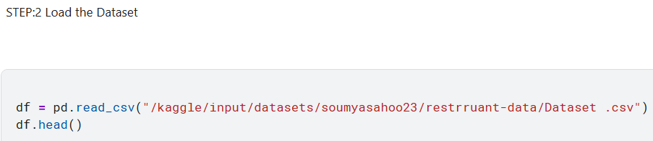
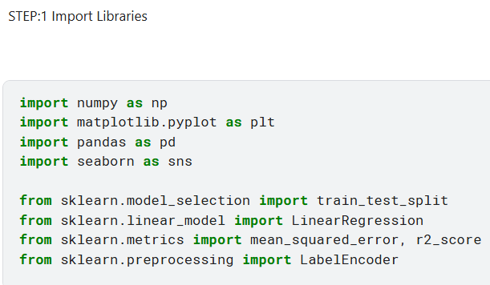

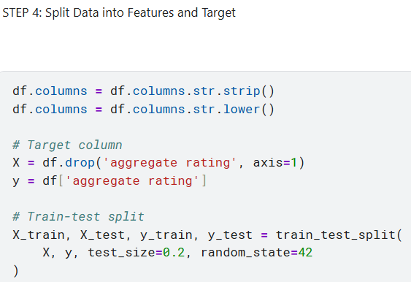
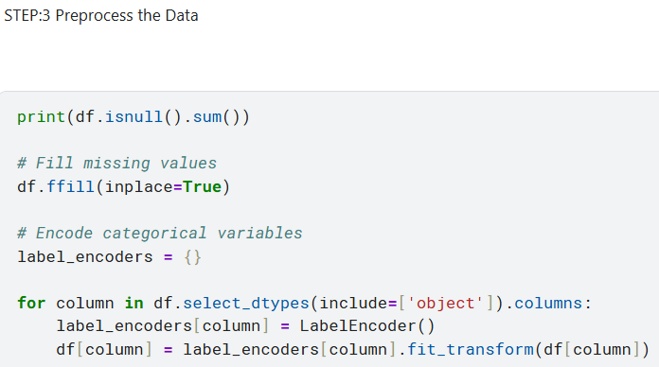

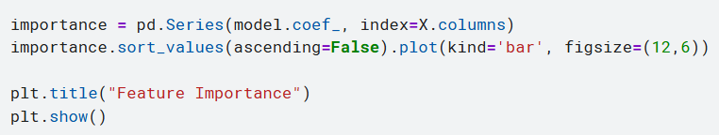
TASK:2
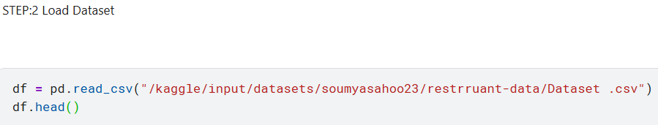
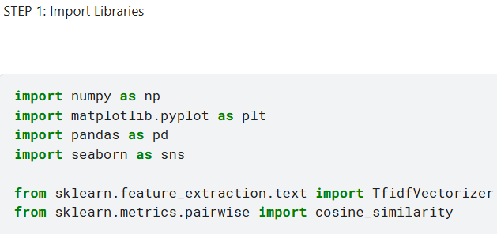

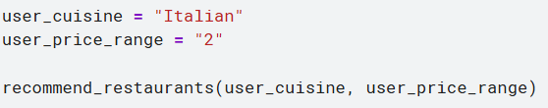
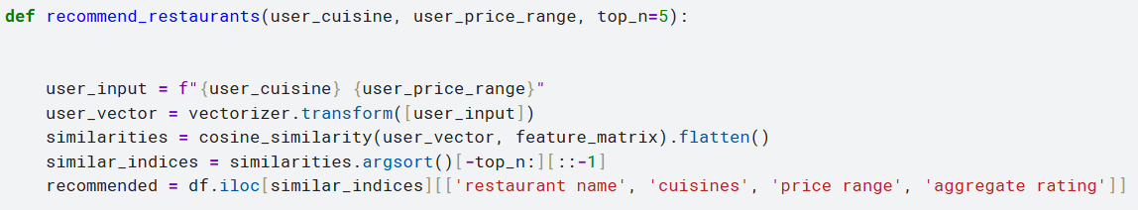

TASK:3 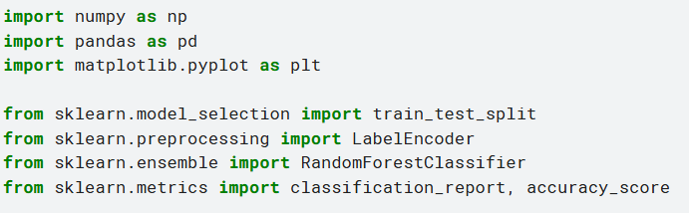
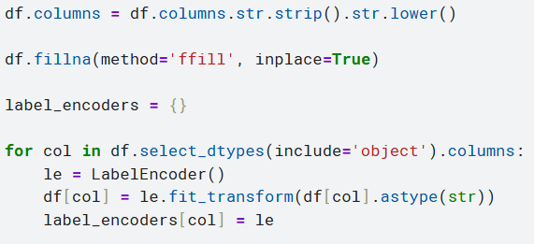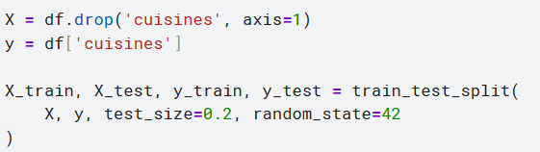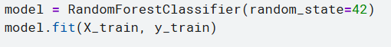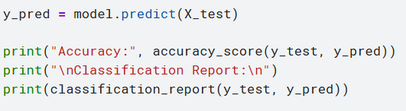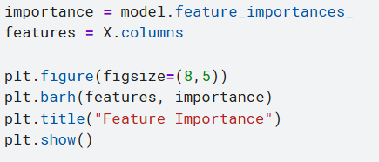
TASK:4
